How to USE OF Variable IN SQL With Example

CREATE TABLE SalesData (
SaleID INT PRIMARY KEY,
SalesPerson VARCHAR(50),
Region VARCHAR(20),
SaleAmount DECIMAL(10,2),
SaleDate DATE
);

INSERT INTO SalesData (SaleID, SalesPerson, Region, SaleAmount, SaleDate)
VALUES
(1, 'Sumit', 'North', 5000, '2025-01-01'),
(2, 'Anita', 'East', 3000, '2025-01-03'),
(3, 'Ravi', 'North', 2500, '2025-01-05'),
(4, 'Pooja', 'West', 4500, '2025-01-07'),
(5, 'Raj', 'East', 4000, '2025-01-10'),
(6, 'Sumit', 'North', 5200, '2025-01-11'),
(7, 'Anita', 'East', 3100, '2025-01-12'),
(8, 'Ravi', 'North', 2700, '2025-01-13'),
(9, 'Pooja', 'West', 4800, '2025-01-14'),
(10, 'Raj', 'East', 4200, '2025-01-15'),
(11, 'Sumit', 'North', 5300, '2025-01-16'),
(12, 'Anita', 'East', 3300, '2025-01-17'),
(13, 'Ravi', 'North', 2900, '2025-01-18'),
(14, 'Pooja', 'West', 4900, '2025-01-19'),
(15, 'Raj', 'East', 4300, '2025-01-20'),
(16, 'Sumit', 'North', 5400, '2025-01-21'),
(17, 'Anita', 'East', 3500, '2025-01-22'),
(18, 'Ravi', 'North', 3100, '2025-01-23'),
(19, 'Pooja', 'West', 5000, '2025-01-24'),
(20, 'Raj', 'East', 4400, '2025-01-25');

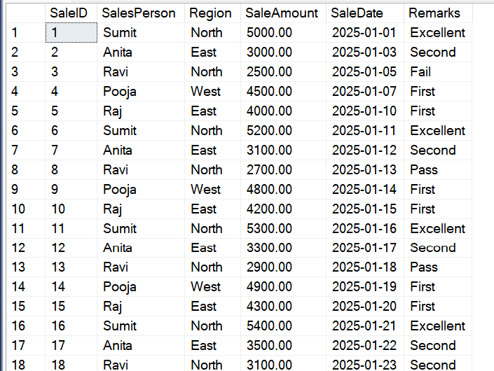
Q-1 Find out the all sales Amount which is greater then 4500

This creates a variable called @SalesThreshold that can hold a decimal number with 2 digits after the decimal point. And puts the value 4500.00 into your variable. Use Variable in a query like below.
Declare @SalesThreshold decimal(10,2) ---Declare Variable

Set @SalesThreshold=4500 --Initialize Variable

Select * from SalesData where SaleAmount<@SalesThreshold -Variable use

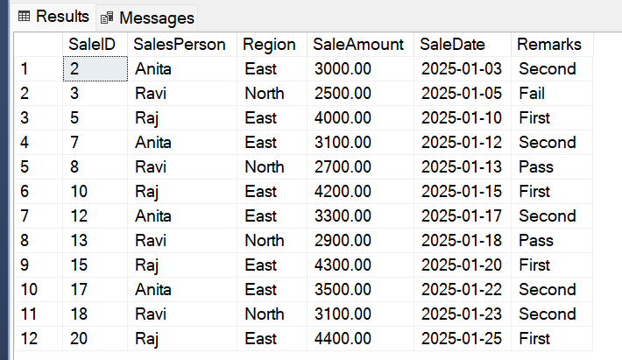

Q-2 -- Total Sales by a Specific Person
Declare @SalesPerson Varchar(50)='Sumit'

Select sum(SaleAmount) as TotalSales from SalesData where SalesPerson=@SalesPerson
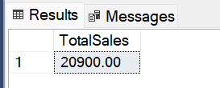

Q.3-- find out the count of Region--'East'
Declare @Region Varchar(50)='East'

Select Count(*) as RegionCount from SalesData where Region=@Region
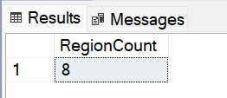

Q.4 Loop Over Sale IDs (Print Only)
Declare @SalesID Int=1

while @SalesID<=5
begin
--Select SalesPerson,Region,SaleAmount from SalesData where SaleID<@SalesID
Print 'Processing SalesID' +' '+ Cast(@SalesID AS VARCHAR)
SET @SalesID=@SalesID+1
END
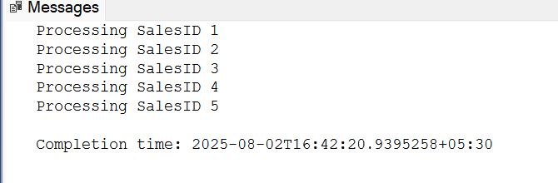

Q.5 Find out Sales Greater Than a Given Amount
Declare @SalesAmount int=4500

select * from SalesData where SaleAmount<@SalesAmount
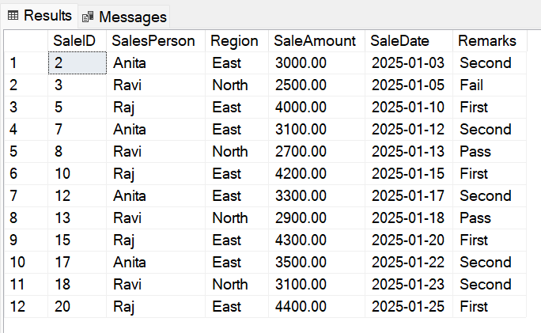

Q.6 Total Sales for a Custom Date Range
Declare @StartDate Date='2025-01-10';
Declare @EndDate Date='2025-01-20';

Select sum(SaleAmount) as TotalSales from SalesData where SaleDate between @StartDate and @EndDate

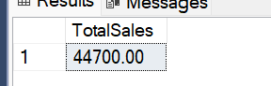

Q.7 Find out sales of North Region where SalesAmount
Greater then 5000
Declare @Regions Varchar(20)='North'

Declare @Threshold Decimal(10,2)=5000

Select * from SalesData where Region=@Regions and SaleAmount>@Threshold
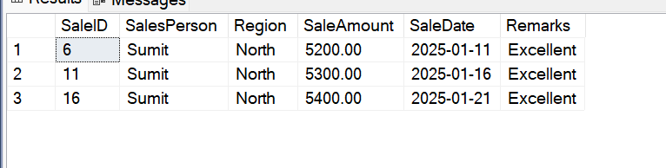

Q.8 Find out top 4 sales using variable
Declare @Topn Int=4

Select Top(@Topn) * from SalesData Order by SaleAmount Desc
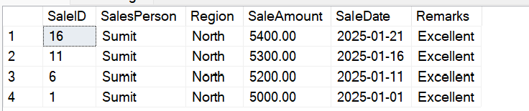

Q.9--------- Insert into Another Table Based on Variable, insert
only which data where SalesAmount Greater then 5000
CREATE TABLE HighSales (
SaleID INT,
SalesPerson VARCHAR(50),
SaleAmount DECIMAL(10,2)
);
Declare @TargetAmount Decimal(10,2)=5000

Insert into HighSales Select SaleID,SalesPerson,SaleAmount from SalesData where SaleAmount>=@TargetAmount
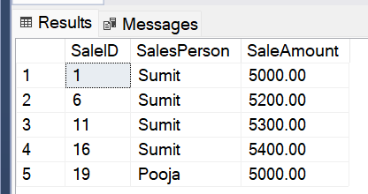

Q.10- Add Status column where Sales Amount Greater then 4500
should be Eligible else Not Eligible
Declare @BonusThreshold Decimal(10,2)=4500

Select SalesPerson,SaleAmount,
Case when SaleAmount>=@BonusThreshold then 'Eligible'
else
'Not Eligible'
end as Status
from SalesData

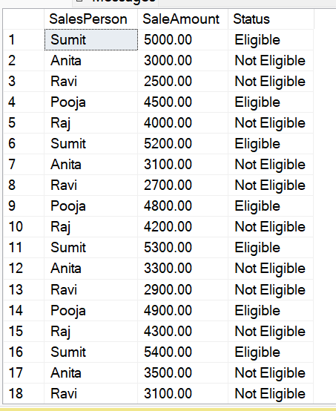

Q.11 Add a column Name as a Performance Grade where you need to fill the records
according to below Criteria
1.Sale Amount >=4700 ‘ Top Performer’
2.Sales Amount >=3000 ‘Average’
3. Else ‘Need to Improvement’

Declare @Score decimal(10,2)
set @Score=4700

Select SaleID,SalesPerson,SaleAmount,
Case
When SaleAmount>=@Score then 'Top Performer'
When SaleAmount>=3000 then 'Average'
else
'Need Improvement'
end as Performance_Grade
from SalesData

